# **Sky di Gioia** **by** **Giorgio Armani**

Sky di Gioia by Giorgio Armani is a Floral Fruity fragrance for women. **Sky di Gioia** was launched in 2016. Top notes are Litchi and Pear; middle notes are Pink Peony and Rose; base notes are Blackberry, White Musk and Cedar.

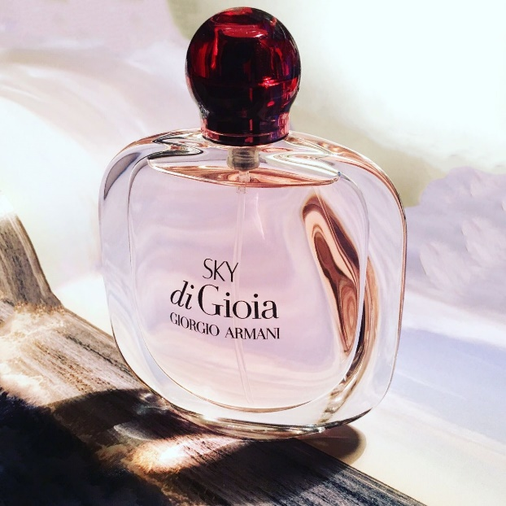In the spring of 2017, the collection is expanded with another edition, Sky di Gioia, which offers "an infinite space of dreams."

Sky di Gioia is inspired by the natural beauty of the sunrise over the sea surface. Also, it carries a positive message of hope; the start of every day brings an infinity of new possibilities, and every dawn is a promise of optimism. The perfume notes include lychee, pink peony, rose and cedar.

The fragrance is available as a 30, 50 and 100 ml Eau de Parfum.